**question 12**

In 1948, Austin Bradford Hill, designed a study to test a new treatment for tuberculosis that at the beginning of the study there was no evidence whether it would be any better or worse than bed rest. He randomly assigned some patients who volunteered to be a part of this study to receive the treatment Streptomycin, an antibiotic. The other patients received only bed rest as the control group. Hill then observed the patients’ outcomes: which patients died and which recovered. The results of the study are shown below.  
  
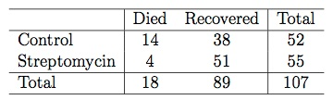  
  
We use the following simulation test if there is a difference between the recovery rates under the two treatments: We write “died” on 18 index cards and “survived” on 89 index cards to indicate whether or not a patient died. Next, we shuffle the cards and deal them into two groups of 52 and 55, for control and treatment, respectively. We then calculate the simulated difference between the recovery rates in Streptomycin and control groups (*p̂Streptomycin − p̂Control*), and record this value. We repeat this simulation 100 times. The histogram below shows the distribution simulated difference between the recovery rates in these 100 simulations.   
  
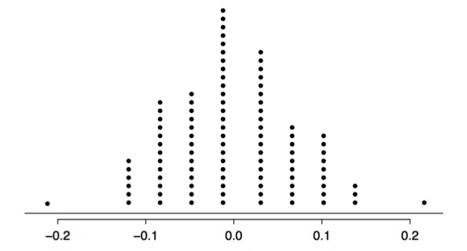  
  
Which of the following is correct? Choose **all** that apply (there are multiple correct answers).

|  |  |  |  |
| --- | --- | --- | --- |
| **Your Answer** |  | **Score** | **Explanation** |
| The alternative hypothesis should be that there is a difference between the recovery rates under the two treatments. | Inorrect | 0.00 | The evidence could go either way so we should consider any difference between the two treatments. |
| The difference between the survival rates in the control and treatment groups appear to be simply due to chance. | Correct | 0.11 | The observed difference between the recovery rates is  *p*^*Streptomycin*−*p*^*control*=5155−3852=0.93−0.73=0.20  There is 1 simulation where the simulated difference is ≥0.20, and since we're doing a two sided hypothesis test, the p-value is 0.01×2=0.02. This is considered unusually low, and hence not due to chance. |
| Streptomycin treatment appears to be effective in treating tuberculosis since the observed difference in recovery rates would be considered unusual based on the simulation results. | Correct | 0.11 | The observed difference between the recovery rates is  *p*^*Streptomycin*−*p*^*control*=5155−3852=0.93−0.73=0.20  There is 1 simulation where the simulated difference is ≥0.20, and since we're doing a two sided hypothesis test, the p-value is 0.01×2=0.02. This is considered unusually low. |
| The conclusion of this study is generalizable to all tuberculosis patients. | Correct | 0.11 | Since the sample is comprised of volunteers, we can’t generalize the results to all tuberculosis patients. |
| Streptomycin treatment does not appear to be effective in treating tuberculosis since the observed number of deaths in the treatment group would not be considered unusual based on the simulation results. | Correct | 0.11 | The observed difference between the recovery rates is  *p*^*Streptomycin*−*p*^*control*=5155−3852=0.93−0.73=0.20  There is 1 simulation where the simulated difference is ≥0.20, and since we're doing a two sided hypothesis test, the p-value is 0.01×2=0.02. This is considered unusually low, and hence we would reject the null hypothesis and hence conclude that the data suggest a difference between the two treatments. |
| Based on this study we can conclude a causal relationship between Streptomycin and better tuberculosis recovery rate. | Correct | 0.11 | Also, since this is an experiment we can deduce causation. |
| The alternative hypothesis is that the Streptomycin treatment is more effective than bed rest. | Inorrect | 0.00 | The evidence could go either way so we should consider any difference between the two treatments. |
| If Streptomycin and bed rest are equally effective in curing tuberculosis, the probability of observing a difference in the recovery rates at least as high as the one observed is 2%. | Inorrect | 0.00 | The observed difference between the recovery rates is  *p*^*Streptomycin*−*p*^*control*=5155−3852=0.93−0.73=0.20  There is 1 simulation where the simulated difference is ≥0.20, and since we're doing a two sided hypothesis test, the p-value is 0.01×2=0.02. |
| Hill’s study is observational. | Correct | 0.11 | No, this is an experiment. |
| Total |  | 0.67 / 1.00 |  |